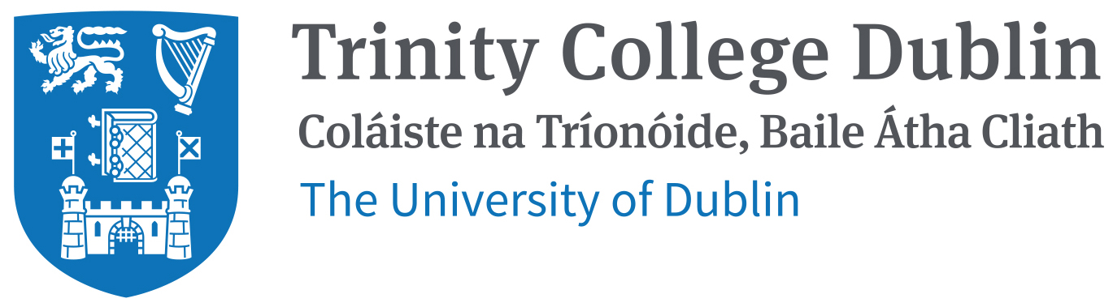

Computer-Aided Drug Design Symposium and Workshop
Linking Design, Biology, Chemistry and Medicine
3rd & 4th May 2018, Trinity College Dublin, Ireland
ABSTRACT SUBMISSION FORM
Please submit your abstract online by 15th April 2018
Notification of acceptance or rejection will be sent to all submitting authors by 23rd April 2018.
NB: The subject of the message should begin with “Abstract, followed by the surname of the participant”. Please rename this file into: Name of the presenting author.doc. If there is more than one abstract from the same author, the name of the author should be followed by a corresponding number. Send your abstract submission form to cadd2018@tcd.ie

Select your preferred presentation format: Poster presentation Oral communication (15 min)
Title of Abstract (Bold, Block Capitals).
Author(s)’ name(s), separated by commas (initials separated by full stop only, space family name comma, repeat as necessary). The presenting author should be underlined. Do not add titles (e.g. Prof., Dr., etc)..
Type text in Times New Roman 11. The abstract should be of an appropriate scientific standard and be informative. It should include sections on Background; Aims or Objectives; Methods; Results; Conclusions (without the titles of the sections). It is not satisfactory to state: "the results will be discussed". No Tables but one Figure is permitted.
The length of the text (excluding title, authors and institution) should NOT EXCEED 2000 characters (with spaces).

